University of Pannonia
Faculty of Information Technology
[Name of the department]
[Name of the course]
THESIS
[Title of the thesis -according to the topic description]
[Name of the author]
Supervisor: [Name of the supervisor]
[Consultant(s) if relevant]
[year]

Description of the task
The scanned description of the task must be inserted here.

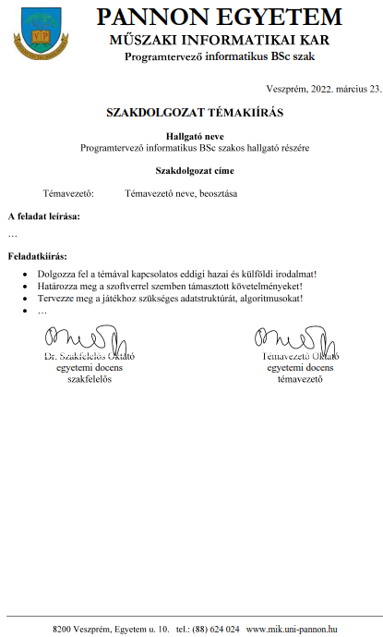

Student’s declaration
Undersigned, <<name of the student>> declare, that this thesis has been prepared at the <<name of the department>> at the University of Pannonia in order to get the <<name of the qualification>>.
I confirm that this thesis and the work presented in it are my own and has been generated by me as the result of my own original research.
I am aware of the fact that the results enclosed in the Master Thesis can be used freely by the department announcing the topic.
Date: [day, month, year], Veszprém

<<name of the student>>

Supervisor’s declaration
Undersigned <<name of the supervisor>> as a supervisor declare the master thesis of <<name>> has been prepared at the <<name of the department>> in order to gain the qualification of <<qualification>>.
I agree to officially submit this document for final defence.
Date: [day, month, year], Veszprém

<<name of the supervisor>>
Acknowledgement
The student expresses his/her acknowledgement for all, who gave him/her help (theoretical, practical, moral).
Please enter all cooperation, references or relevant information that contributed directly or indirectly to relevant information supporting the validity of this document.
Abstract
The abstract must contain points (short and accurate summary) as follow:
- name of the topic
- description of the task
- methodology of the solution
- results
- keywords (4-6 words)
- the abstract must not exceed 1 A4 page printed on the front page
The abstract needs to be prepared in Hungarian as well as in English. Order of the abstract is equal to the language of the thesis itself. The formatted text of the abstract: Times New Roman, 12 pt. normal, justified, 1.5 lines
Keywords: [list 4-6 keywords, separated by commas]
Tartalmi összefoglaló idegen nyelven
Tartalmi összefoglaló magyarul vagy a hallgató anyanyelvén. Az összefoglalónak tartalmaznia kell (rövid, velős és összefüggő megfogalmazásban) a következőket:
- téma megnevezése,
- megoldott feladat megfogalmazása,
- megoldási mód,
- elért eredmények,
- kulcsszavak (4-6 darab)
- terjedelme nem lehet több 1 A4-es oldalnál.
Az összefoglalót magyar és angol nyelven kell készíteni. Sorrendben a dolgozat nyelvével megegyező kerül előrébb. A cím Title stílusú, formázása: Times New Roman, nagybetű, 14 pt, félkövér, középre igazított; az összefoglaló Normál stílusú, formázása: Times New Roman, 12 pt, sorkizárt, 1.5-ös sortávolság.
Kulcsszavak: [4-6 kulcsszó felsorolása, vesszővel elválasztva]

Table of content
Nomenclature 8
1. Chapter 9
1.1. SubChapter 9
1.1.1. SubChapter 9
2. New Chapter 10
2.1. New SubChapter 10
3. Instuctions 10
Bibliography 12
Appendices 13
List of Figures 14
List of Tables 15

Nomenclature
AI: | Artificial Intelligence
GPU: | Graphical Processing Unit
API: | Application Programming Interface
CPU: | Central Processing Unit
GUI: | Graphical User Interface
HCI: | Human Computer Interaction
CIS: | Cognitive Information System

Chapter
Text: Times New Roman, 12pt, 1.5 lines, justified
Variables in bold in the text
New paragraph: the first line of the new paragraph’s indentation is 1 cm
Titles are numbered, Heading 1:14pt, Times New Roman, bold, further Heading: 12pt, bold, Times New Roman. The first line after the title has to begin at the beginning of the next line (First paragraph style)
General rules
- space precede and follow all signs
- every point, comma, question mark, etc. is followed by a pace
- brackets: normal not italics
Length: the manuscript has to contain at least 40 and maximum 60 pages
Margins: all the margins, from bottom and from top, from right and left 2,54 cm, 1 cm gutter
Pages: page numbers must be on the bottom middle of each page
Headers contain the title of the paragraph in the middle.

SubChapter
The main part is determined by the supervisors and the student together, this part is at least 2/3 part of the whole thesis without quotations, but at least 40 pages.
Quotations longer than some sentences MUST NOT be inserted into the manuscript. Longer quotations have to be inserted in the appendices.

SubChapter
Figures and formulas should be centred, captioned and numbered in the Thesis. The caption should be in Caption style and placed below the figure.
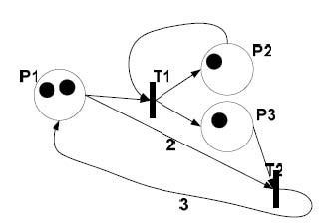
1 Figure caption (indicate source if necessary) [1]

SubChapter
Tables should be centred, captioned, and numbered in the thesis. The table caption should be in Caption style and placed above the table.
Within a table, the text should be vertically centred. Horizontal alignment of data is determined by the data content (decimal alignment is recommended for decimal values). [2] [3]
1. Table in the middle, subtitled and numbered (source indicated)
 | Measurements
Data 1. | Data 2. | Data 3.
1,5 | 2,1 | 1,8

New Chapter

New SubChapter
The bibliography word is in Title style. The bibliography is automatically generated. Bibliography references are numbered in square brackets in the text. The order of the bibliography is determined by the citation in the text.
Internet addresses are without underlining. For Internet addresses, the date of the last visit to the web page should be given in parentheses after the url.
Numbering of equations below the equation, right justified, according to the pattern (1).
($f\left(x\right)=a_{0}+\sum_{n=1}^{∞}{\left(a_{n}\cos{\frac{nπx}{L}}+b_{n}\sin{\frac{nπx}{L}}\right)}$
(1)

Instuctions
Name of the departments:
- Department of Applied Informatics (Nagykanizsa)
- Department of Computer Science and Systems Technology
- Department of Electrical Engineering and Information Systems
- Department of Information Technology and its Applications (Zalaegeszeg)
- Department of Mathematics

Name of the courses:
- Business Informatics BSc
- Computer Science BSc
- Computer Science Engineering BSc
- Electrical Engineering BSc
- Computer Science Engineering MSc
- Computer Science MSc

Bibliography
[1] | D. J. Wetherall és A. S. Tanenbaum, Computer networks, Pearson Education, 2013.
[2] | T. De Smedt and W. Daelemans, “Pattern for python.,” The Journal of Machine Learning Research, vol. 13, no. 1, pp. 2063-2067, 2012.
[3] | „Záróvizsga információk,” [Online]. Available: https://mik.uni-pannon.hu/index.php/hu/oktatas/zarovizsga.html. [Hozzáférés dátuma: 04 03 2022].
[4] | “Záróvizsga információk,” [Online]. Available: https://mik.uni-pannon.hu/index.php/hu/oktatas/zarovizsga.html. [Accessed 04 03 2022].

Appendices
Folder structure:
+chatbot
| backen.bat
| backend.py
| files.doc
| fixedlinks.json
| ipcheck.py
| linkek.json
| linkfix.py
| log.txt
| sqlwriter.py
| textprocessor.py
|
+---backend
| pyvenv.cfg
+---lara
| | entities.py
| | nlp.py
| | parser.py
| | stemmer.py
+---static
| +---css
| | chat.css
| |
| \---js
| chat.js
|
+---templates
| index.html
|
[Note: Files installed by Python's package manager and various cache files have been omitted from the above list, as they would make the above list unreasonably and disproportionately long. However, for the sake of completeness, these files are included in the submitted files.]

List of Figures
1 Figure caption (indicate source if necessary) [1] 9

List of Tables
1. Table in the middle, subtitled and numbered (source indicated) 9

