
University of Pannonia
Faculty of Information Technology
Department
Name of Programme

THESIS
Title of Thesis
Name
Supervisor: Name of Supervisor
External/Internal Co-supervisor: Name of Co-supervisor
Veszprém
year

Thesis Assignment
Insert the scanned thesis assignment into the document.
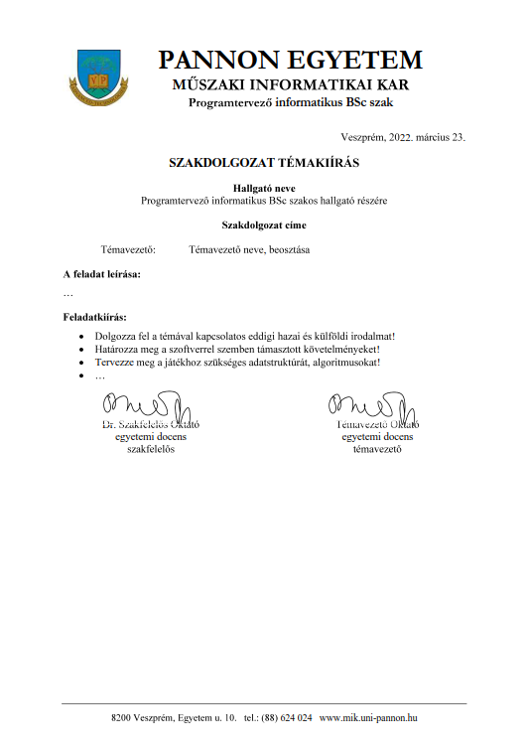

Student Declaration
I, the undersigned Name student (Neptun code: YOUR NEPTUN CODE), hereby declare, simultaneously with the submission of the thesis, that the Title of Thesis titled THESIS (hereinafter: thesis) was prepared at the University of Pannonia Faculty of Engineering Department, in order to obtain the degree qualification.
I declare that in the thesis I used only the cited and referenced sources, and I referenced these in accordance with the applicable citation rules.
I declare that the substantive part of the thesis is the result of my own intellectual work, and I have not submitted it at any other institution, programme, or for obtaining another higher education qualification. I acknowledge that in the case of plagiarism or copyright infringement, my thesis may be rejected and disciplinary proceedings may be initiated against me. I further acknowledge that in the case of copyright infringement, the University is entitled to restrict access to the thesis and to remove the document from the electronic closed system designated by the organisational unit supervising the thesis.
I further acknowledge that the University of Pannonia may freely use the results of the thesis for its own purposes, in the absence of a different written agreement, in accordance with the University of Pannonia Intellectual Property Management Policy.
I declare that during the preparation of the thesis I used artificial intelligence tools used.

I declare that during the preparation of the thesis I used the artificial intelligence tools listed in the table below exclusively to support the research or development task; the substantive work, analysis and conclusions are entirely my own intellectual creation.

Technology Used | Method of Use | Generated Content | AI Usage Ratio
GPT-4o (OpenAI) | generating text summary | 2.2 chapter | 80%

Veszprém, 23 September 2026

Name

Supervisor's declaration
I, the undersigned Name of Supervisor , as supervisor of the thesis, declare that the Title of Thesis titled thesis was prepared by Name at the University of Pannonia Faculty of Engineering Department, in order to obtain the degree qualification.
I declare that I permit the thesis to be submitted for defence.
Veszprém, 23 September 2026

Name of Supervisor
Acknowledgements
The student expresses gratitude to all those who provided assistance (theoretical, practical, moral, etc.).

Abstract
Abstract in Hungarian. The abstract should contain (in a concise, substantive and coherent formulation) the following:
- topic name,
- formulation of the solved task,
- method of solution,
- results achieved,
- keywords (4–6 items)
- length must not exceed 1 A4 page.
The abstract must be prepared in both Hungarian and English. The one matching the language of the thesis comes first. The title has Title1 style, formatting: Times New Roman, uppercase, 14 pt, bold, centered; aabstract has Normal style, formatting: Times New Roman, 12 pt, justified, 1.5 line spacing. The first paragraph First paragraph style.
Keywords: [4-6 list keywords, separated by commas]

Abstract
Abstract in English. Style should be the same as the Hungarian version.
Keywords: [list 4-6 keywords]

Table of Contents
List of Abbreviations 8
1. Chapter 9
1.1. Alchapter 9
1.1.1. Alchapter 9
2. New Chapter 10
2.1. New Subsection 10
3. Instructions 11
References 12
Appendices 13
List of Figures 14
List of Tables 15

List of Abbreviations
AI: | Artificial Intelligence (Artificial Intelligence)
GPU: | Graphical Processing Unit (GPU)
API: | Application Programming Interface (API)
CPU: | Central Processing Unit (CPU)
GUI: | Graphical User Interface (GUI)
HCI: | Human Computer Interaction (HCI)
CIS: | Cognitive Information System (CIS)

Chapter
The first paragraph First paragraph style. A other text Normal style.
Headings numbered accordingly: Heading 1, Heading 1.1, Heading 1.1.1, Heading 1.1.1.1 styles can be used.
General rules:
- every mathematical operator (arithmetic, set-theoretic, etc.) is preceded and followed by a space
- every punctuation mark (period, comma, question mark, stb,) is followed by a space
- parentheses: upright (not italic)
Language note: follow the relevant style guide — Hungarian Orthography Rules for Hungarian, or the appropriate American/British style guide for English. Length: see the programme-specific thesis requirements document. Margins: standard (top, bottom, left and right margins all 2.54 cmek, binding margin 1 cm).) Page numbering: centered at the bottom. Header content: chapter titles, centered per chapter.
All source code fragments source code and excerpts in the document must be formatted with the Code style for a consistent appearance. Code must be inserted as text, not as an image. Below each code excerpt, Caption style place a caption in the following format: "1. kcode excerpt: Brief description”.

public class HelloWorld {
public static void main(String[] args) {
System.out.println("Hello, World!");
}
}
1. ccode excerpt: Hello World program Java nyelven.

Alchapter
The substantive content is agreed upon jointly by the supervisor and the student, and must constitute at least 2/3 of the thesis excluding marked quotations.
Verbatim quotations longer than a few sentences must NOT be included in the main body. Longer quotations should be placed in the appendixn must be placed.

Alchapter
Figures and formulae, centred, captioned and numbered must be included in the thesis. Use the “In Line with Text” setting for figures as a line-break method. UseCaption style for captions.
A References → Cross-reference dialog allows inserting references to figure, table, heading or equation captions in the text. From the "Reference type" list, select the element type (e.g. Figure, Table, Heading); in the "Insert reference to" field choose the displayed information (e.g. Only label and number → "Figure 1"); then click the desired item in the list. Cross-references are stored as field codes, so if the order of figures or chapters changes, update them throughout the document by pressing F9 (or right-click → Update Field) — this should be done before printing or submission.
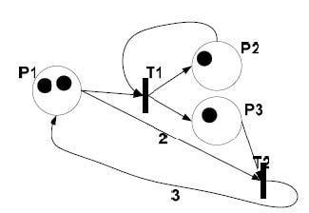
1. figure: figure caption (if necessary, with source citation) [1]

Alchapter
Tables centred, captioned and numbered must be included in the thesis. The table caption is placed above the table, Caption style. [2] [3]

1. table name, with source citation if necessary
 | Measured Data
Data 1. | Data 2. | Data 3.
1,5 | 2,1 | 1,8

New chapter

New alchapter
References citations in the text are given in square brackets with numbers. The order of references is determined by in-text occurrence.
A References → Manage Sources window, enter the bibliographic items (author, title, year, publisher, etc.); the citation style is selected from the References → Style dropdown (e.g. IEEE, APA). Once an item is added to the source list, insert it into the text using Insert Citation button, and Word formats it automatically. The reference list is created using the References → Insert Bibliography command, and it can be updated based on the inserted items (right-click → Update Field). If the template expects a .bib source from LaTeX, it must first be converted to a Word source list using Zotero or JabRef, as Word's built-in manager does not natively read BibTeX format.
URLs must be written without underlining. For web addresses, the date of last access follows thez URL in parentheses.
Az equations are numbered below the equation, right-aligned, as shown in the example (1) (Equation Number Equation Number style).
The built-in equation editor can be opened via Insert → Equation menu item (or Alt+= shortcut). The equation is inserted as a standalone object that can be edited using the mathematical symbol palette and OMML input syntax. For a numbered equation, the most reliable method is a three-column, borderless table: the middle cell contains the equation, the right cell contains the number (e.g. (1)). If numbering needs to be managed automatically, instead of a static number use a List Number List Number style paragraph or a field code anchored to a right tab stop — these can be updated automatically.
($f\left(x\right)=a_{0}+\sum_{n=1}^{∞}{\left(a_{n}\cos{\frac{nπx}{L}}+b_{n}\sin{\frac{nπx}{L}}\right)}$
(1)

References
[1] | T. De Smedt and W. Daelemans, “Pattern for python.,” The Journal of Machine Learning Research, vol. 13, no. 1, pp. 2063-2067, 2012.
[2] | "Graduation Information," [Online]. Available: https://mik.uni-pannon.hu/index.php/hu/oktatas/zarovizsga.html. [Accessed: 04 Mar 2022].
[3] | D. J. Wetherall and A. S. Tanenbaum, Computer networks, Pearson Education, 2013.

Appendices
Folder Structure
+chatbot
| backen.bat
| backend.py
| files.doc
| fixedlinks.json
| ipcheck.py
| linkek.json
| linkfix.py
| log.txt
| sqlwriter.py
| textprocessor.py
|
+---backend
| pyvenv.cfg
+---lara
| | entities.py
| | nlp.py
| | parser.py
| | stemmer.py
+---static
| +---css
| | chat.css
| |
| \---js
| chat.js
|
+---templates
| index.html
|
[EXAMPLE!!! Note: Files installed by Python's package manager and various cache files were omitted from the above list to avoid making it unreasonably long. However, these files are included among the submitted files for completeness.]

List of Figures
1. figure: figure caption (if necessary, with source citation) [1] 1

List of Tables
1. table (source citation) [2] 1

Setting PDF Metadata
The submitted PDF must contain the following 11 metadata fields, correctly filled in. Fields 1–4 are transferred to the PDF from Word's File → Info → Properties panel; fields 5–11 must be added afterwards using the Sejda online metadata editor.
# | Field | Value to enter
1 | Author | your full name
2 | Title | the final title of the thesis
3 | Subject | the abstract (200–500 words)
4 | Keywords | 10–20 keywords, separated by commas
5 | Language | hu-HU or en-US
6 | Department | your programme name
7 | Degree | BSc, MSc or FOKSZ
8 | Type | Thesis
9 | Supervisor | your supervisor’s name
10 | Consultant | your consultant's name (if applicable)
11 | SubmissionDate | submission date: YYYY-MM-DD

1. Fields fillable in Word (fields 1–4)
Open File → Info, then in the Properties panel on the right, fill in the following four fields:
Title – the final title of the thesis
Author – your full name
Subject – the complete abstract text (200–500 words)
Keywords – 10–20 keywords, separated by commas

2. Exporting as PDF/A from Word 365
File → Save As → PDF. In the dialog that appears, click Options…, check the PDF/A-compliant (ISO 19005-1) checkbox, make sure the Document Properties checkbox is checked, then save the file.

3. Adding custom fields using the Sejda online tool (fields 5–11)
Upload the exported PDF/A file to the Sejda PDF Metadata Editor (sejda.com/pdf-metadata-editor), select Change metadata, verify the content of fields 1–4, then use the Add new field button to add the following custom fields:
Language – hu-HU (or en-US for an English thesis)
Department – your programme name
Degree – BSc, MSc or FOKSZ
Type – Thesis
Supervisor – your supervisor’s name
Consultant – your consultant’s name – if there is no consultant, omit this field
SubmissionDate – submission date in YYYY-MM-DD format (e.g. 2026-05-15)
After filling in all fields, click Update PDF Metadata, download the updated file, and before submission verify that all 11 fields appear correctly in the PDF metadata.

If your answer is NOT "used", delete the following paragraph and Table from the thesis.

